26.67: 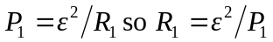
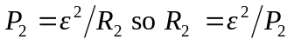

a) When the resistors are connected in parallel to the emf, the voltage across each resistor is and the power dissipated by each resistor is the same as if only the one resistor were connected. 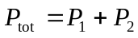
b) When the resistors are connected in series the equivalent resistance is 